AN INDUCTION GENERATOR-BASED AC/DC HYBRID ELECTRIC POWER GENERATION SYSTEM FOR MORE ELECTRIC AIRCRAFT
ABSTRACT
In more electric aircraft (MEA) system, both ac and dc electric power with multiple voltage levels are required for various aircraft loads. This paper presents an induction generator-based ac/dc hybrid electric power generation system for MEA. In the proposed system architecure, a high-speed induction starter/generator and a low-speed induction generator are installed on the high pressure (HP) and low pressure (LP) spools of the engine, respectively. In generating mode of operation, all of the constant voltage variable frequency ac power is generated by the HP generator while the dc power demand is shared by both HP and LP generators. A control scheme is developed to regulate the ac load voltage and coordinate dc power generation between the two generators. The proposed induction generator based ac/dc hybrid generation system results in reduced hardware requirement compared with both ac and dc primary generation systems.

BLOCK DIAGRAM FOR PROPOSED SYSTEM

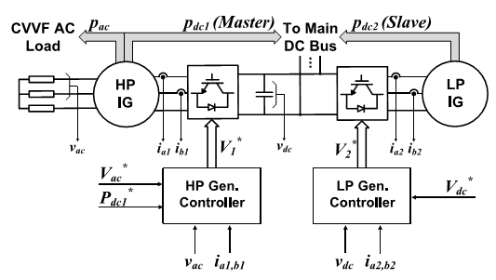
Fig. 1. Overall closed-loop control scheme for the proposed ac/dc hybrid generation system
DESIGNG SOFTWARE AND TOOLS:
MAT LAB /SIMULATION Software and simu power systems tools are used. Mainly control system tools, power electronics and electrical elements tools are used.

